Tunxis Wellness Programs – TUNXIS.EDU/COUNSELING
LIMITED SEATS-SIGN UP TODAY: https://forms.office.com/r/EPdiqF49e3
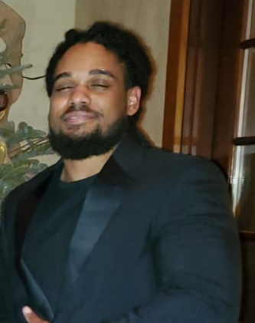

Physical fitness
Free Workshop, Pizza and a Drawing!
Tuesday, February 14, 2:30-4:00
(includes Q&A)
Founders Hall
- Understand the connection between physical fitness, mental health and all aspects of life.
- Learn workouts that you can do anywhere!
- Workshop presented by Fitness Trainer, Ochena Kelley from KFit.

The R&R - Visit the Relaxation & Resource Room, Inside the ASTC, Room 6-109
For event questions, email tx-counseling@tunxis.edu

