Tunxis Wellness Programs – TUNXIS.EDU/COUNSELING
LIMITED SEATS-SIGN UP TODAY: https://forms.office.com/r/EPdiqF49e3

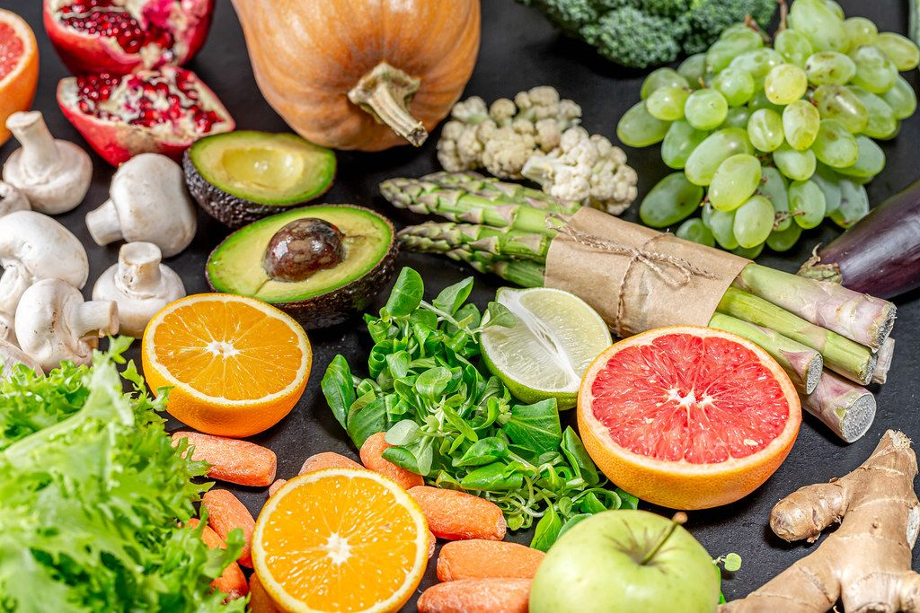

Healthy eating on a budget Free workshop
Tuesday, February 21, 2:30-4:00
Founders Hall
Learn how to make 7 meals for $35!
Walk away with a couple of FREE meals!

Workshop presented by professional chef,
Stacey Smith of Smith’s Food Service

The R&R - Visit the Relaxation & Resource Room, Inside the ASTC, Room 6-109
For event questions, email tx-counseling@tunxis.edu

