**Tunxis Wellness Programs – TUNXIS.EDU/COUNSELING**

Dog therapy with jake

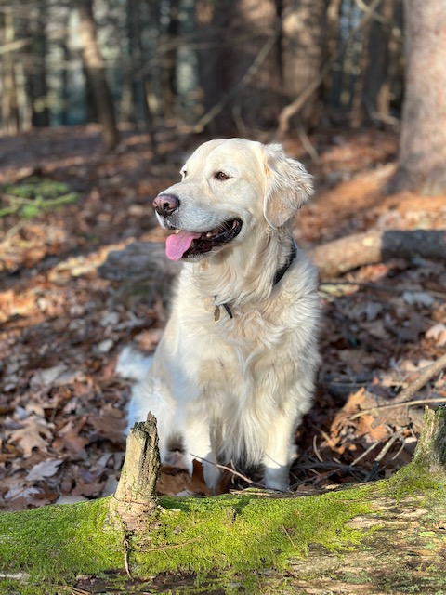 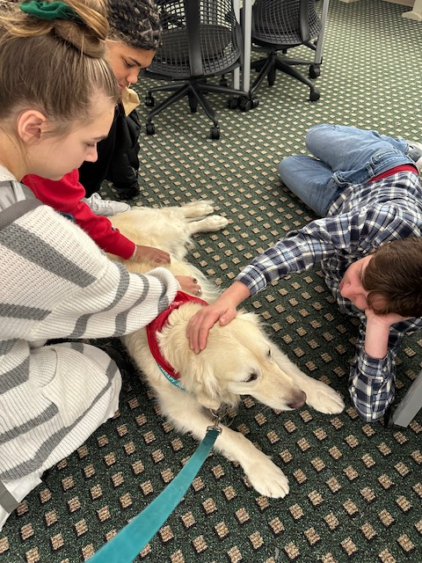 

**Stop by for a visit with Jake and his trainer, Laurie,**

**to enjoy the benefits of dog therapy.**

Jake is a five-year-old English Cream Golden Retriever. He has been a therapy dog for 3 years, and visits elementary, middle and high schools, colleges and hospice patients.  When not “working” he loves to swim, hike, play fetch, do scent work and EAT.

Thursday, February 23,

11:00 am - 12:00 pm

Main Lobby, 100 Building

Visit the Relaxation & Resource Room, Inside the ASTC, Room 6-109

For event questions, email [tx-counseling@tunxis.edu](mailto:tx-counseling@tunxis.edu)