Tunxis Wellness Programs – TUNXIS.EDU/COUNSELING
LIMITED SEATS-SIGN UP TODAY: https://forms.office.com/r/EPdiqF49e3

Sleep awareness

Free workshop
Tuesday, March 7, 2:30-4:00
Founders Hall
Free Pizza, Giveaways, & Prize Drawing!

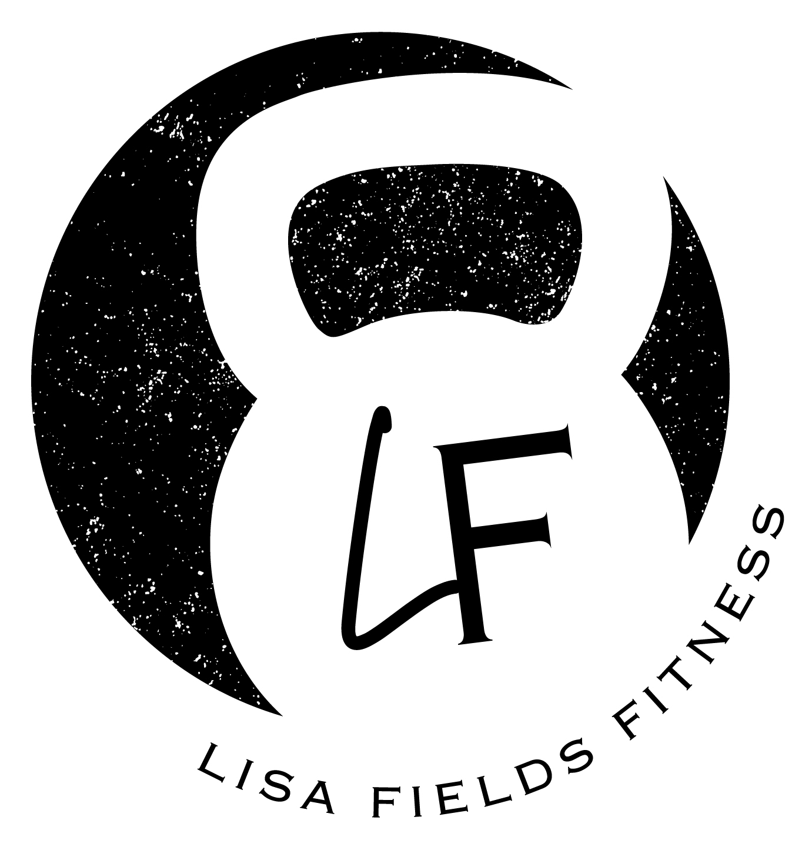
Learn how sleep affects all areas of our life: academics, behavior, mental health, physical health and more.
Develop the skills to get better sleep!
Workshop presented by Personal Trainer,
Lisa Fields from Lisa Fields Fitness -
Certified Personal Trainer, Certified Life Coach,
Certified Nutritionist.

For event questions, email tx-counseling@tunxis.edu

