Tunxis Wellness Programs – TUNXIS.EDU/COUNSELING
For Updates-SIGN UP TODAY: https://forms.office.com/r/EPdiqF49e3 

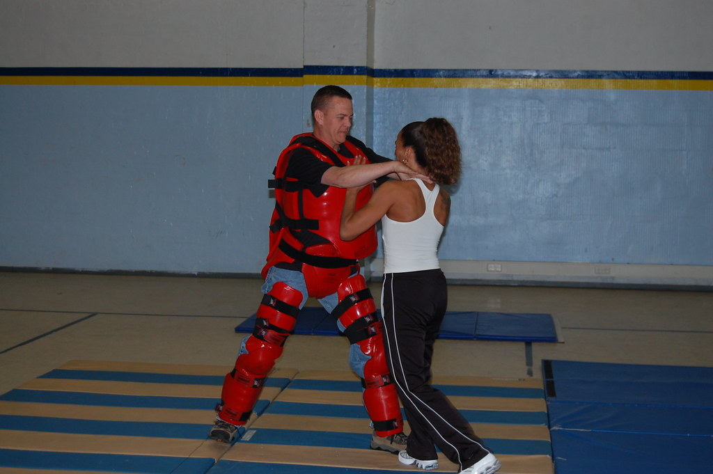

free women’s self defense class

with farmington valley martial arts program
Tuesday, may 2, 1:00-2:00 pm
tunxis courtyard – at spring fling
Learning self-defense can improve your mental and physical health. Check it out!

The R&R - Visit the Relaxation & Resource Room, Inside the ASTC, Room 6-109
For event questions, email tx-counseling@tunxis.edu

